TASK 1

1. Database Design (Normalization):

1. Create the database named "TechShop"

CREATE DATABASE TECHSHOP;

2. Define the schema for the Customers, Products, Orders, OrderDetails and Inventory tables based on the provided schema.

create table Customers(

CustomerID int primary key,

Firstname varchar(50),

Lastname varchar(50),

Email varchar(100),

Phone varchar(20),

Address varchar(255)

);

create table Products(

ProductID int primary key,

ProductName varchar(255),

Description varchar(255),

price decimal(10,2)

);

create table Orders(

OrderID int primary key,

CustomerID int,

Orderdate Date,

foreign key (CustomerID) references Customers(CustomerID)

);

create table OrderDetails(

OrderDetailsID int primary key,

OrderID int,

ProductID int,

Quantity int,

foreign key (OrderID) references Orders(OrderID),

foreign key (ProductID) references Products(ProductID)

);

create table Inventory(

InventoryID int primary key,

ProductID int,

QuantityInStock int,

LastStockUpdate int,

foreign key (ProductID) references Products(ProductId)

);

3. Perform the first three normal forms (1NF, 2NF, 3NF) analysis on the above tables.

1. First Normal form:

All tables are already in 1NF and they don’t contain any repeating groups.

Each table has a primary key and which is uniquely identify each record.

1. Second Normal form:

A table isin 2NF if it is in 1NF and non prime attributes are fully functionally dependent on primary key

Customers table:

No partial dependencies and all non prime attributes are fully functionally dependent on primary key

(CustomerName, Email, Phone, Address) are functionally dependent on (CustomerID)

Products table:

No partial dependencies and all non prime attributes are fully functionally dependent on primary key

(ProductName, price, Category) are functionally dependent on (ProductID)

Orders table:

No partial dependencies and all non prime attributes are fully functionally dependent on primary key

(OrderDate) is functionally dependent on (OrderID)

OrdersDetails table:

No partial dependencies and all non prime attributes are fully functionally dependent on primary key

(Quanity) is functionally dependent on (OrderDetailsID)

Inventory table:

No partial dependencies and all non prime attributes are fully functionally dependent on primary key

(QuantityInStock, LastStockUpdate) are functionally dependent on (ProductID)

All tables are in 2NF

1. Third Normal Form:

A table is in 3NF if it is in 2NF, and no transitive dependencies

Here All the tables are in 3NF

4. Create an ERD (Entity Relationship Diagram) for the database

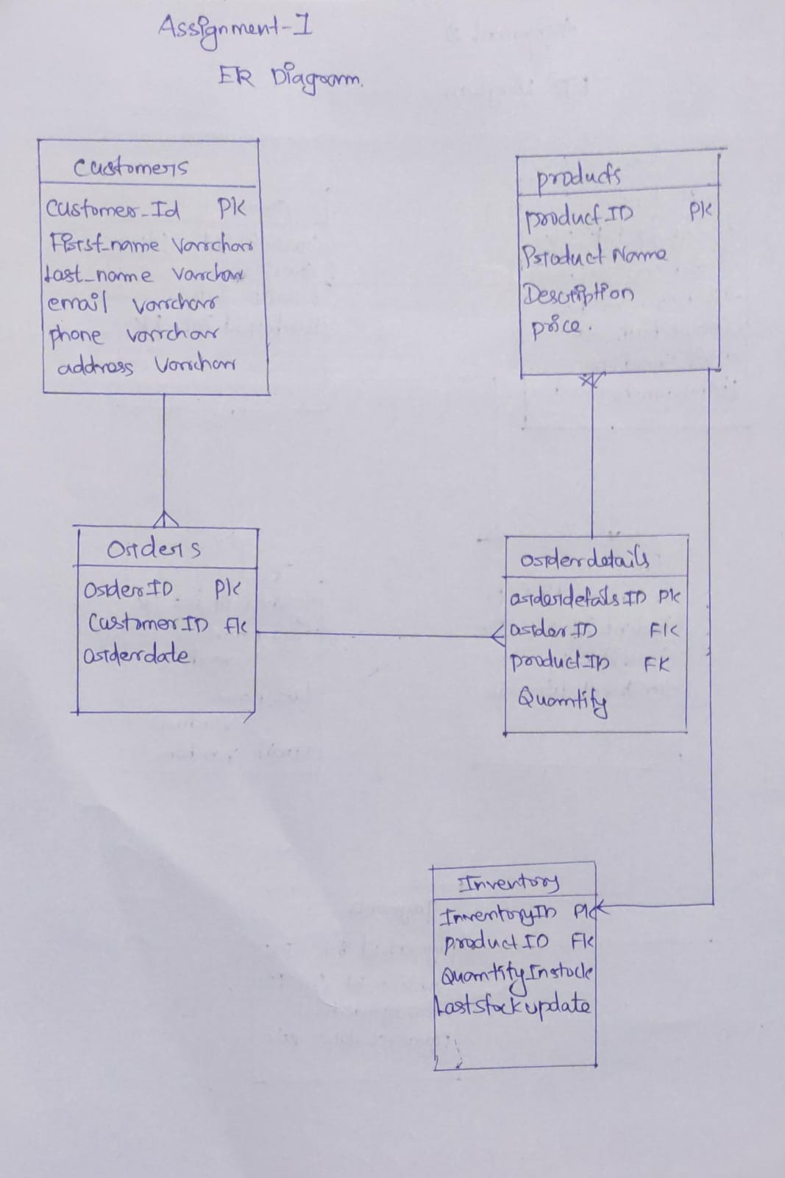

One to many between Customers and orders

One to many between Orders and Orderdetails

Many to one Products and Orderdetails

One to one Products and Inventory